FIRST SETTLERS ON THE NILE

Thousands of years ago, the Sahara was a well-watered plain where wild animals lived. Stone Age people lived there too and hunted the animals.
Slowly the climate changed and the Sahara became a desert. People and animals had to search for a water supply. Some of them reached the land we call Egypt.
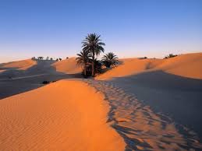
In these times the valley of the river Nile was a marshy jungle where dangerous animals lived. The new comers camped on the edges of the Nile for safety.
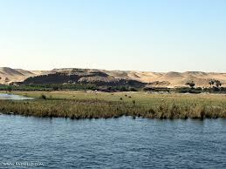
After a while the hunters to learnt to tame animals rather than hunt and kill them. They domesticated dogs, cattle, sheep, pigs, goats and donkeys.
The number of people grew and they were able to clear land near the river and build villages there. They found out how to plant seeds and grew wheat, barley and vegetables. They also discovered how to make pottery, spin and weave flax to make linen clothes and use metals like copper and gold to make tools and weapons.
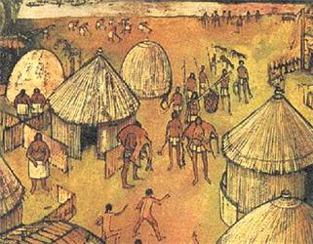
Every year in July, flood waters from the south burst the Nile’s banks and soaked the hard, dry ground. The flood lasted several weeks and was called the ‘Inundation’.
The Ancient Egyptians discovered how to save enough of the flood water to last the whole year. They cut canals and ditches which stored the water and carried it to the fields.

ACTIVITIES:
Read the information on the sheet and then complete the sentences and the crossword.
DOWN:
1. The early Egyptians learned how to make __________ from clay.
3. The famous river in Egypt is the _________.
5. The Egyptians cut __________ and ditches to carry water to their fields.
ACROSS:
2. The flood which lasted several weeks was called the ________________.
4. The Egyptians found out how to grow wheat, ___________, and vegetables.
6. The Egyptians could spin and ____________ flax to make linen clothes.
7. ______________ were one animal domesticated by the Egyptians.
8. The Nile’s floodwaters burst their banks in the month of ____________.

 |  |  |  |  |  |  |  |  |  | 1
 |  | 2 | 3
4
 |  |  |  |  |  |  | 5 |  | 6
 |  |  |  |  | 7
 |  |  |  |  | 8

